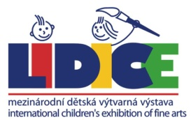 | 51st INTERNATIONAL CHILDREN´S EXHIBITON OF FINE ARTS LIDICE 2023  WORK IDENTIFICATION LABEL - INDIVIDUAL
Name: |  |  |  |  | Age:
Surname: |  |  |  |  | BOY |  | GIRL
Title of the entry: |  |  | Technique
Address:
Region: |  | Town:
Post/ ZIP code: |  | Country:
E-mail : |  | Phone:

